- This is the first screen that allows the user select buy bag, sell bag or exit application
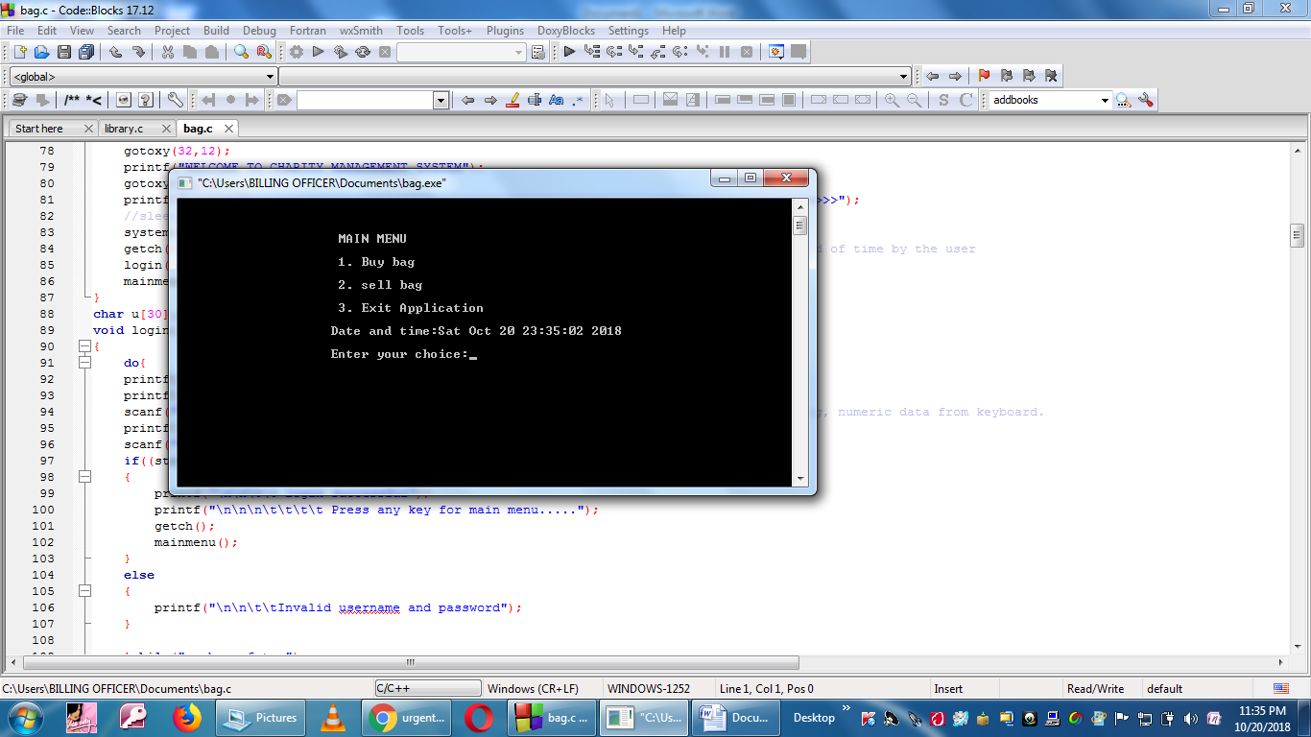
- If the user chooses the first choice, it allows them to make save the number of bags, the location, the description weight and the cost.

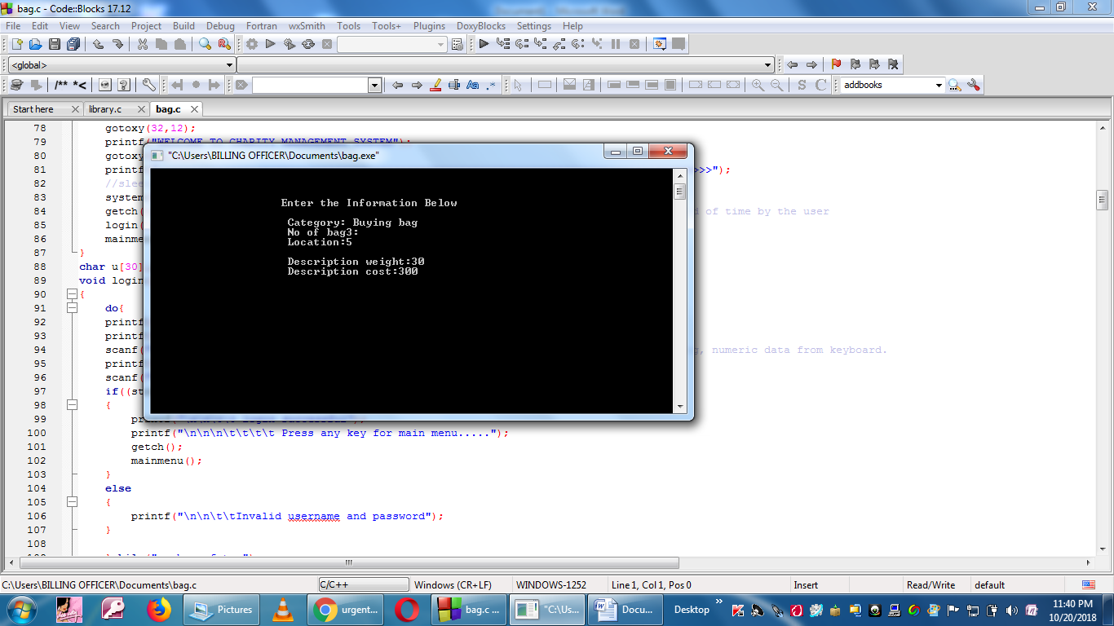

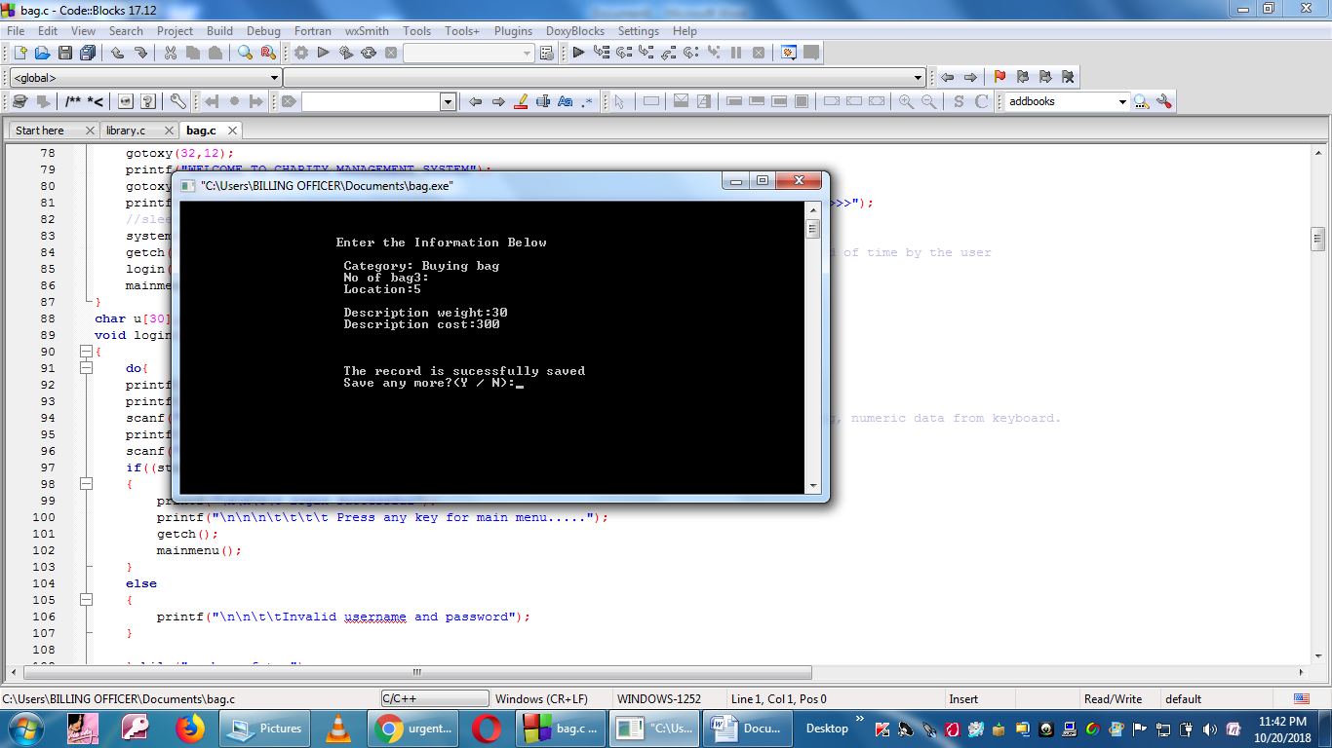
- If the user opts for the second option which is sell the bags, the screen is as this that is prompted.
The selling of the bag is only possible if the user allows it after comparing the description weight and the carrying capacity of the customer buying the bags.
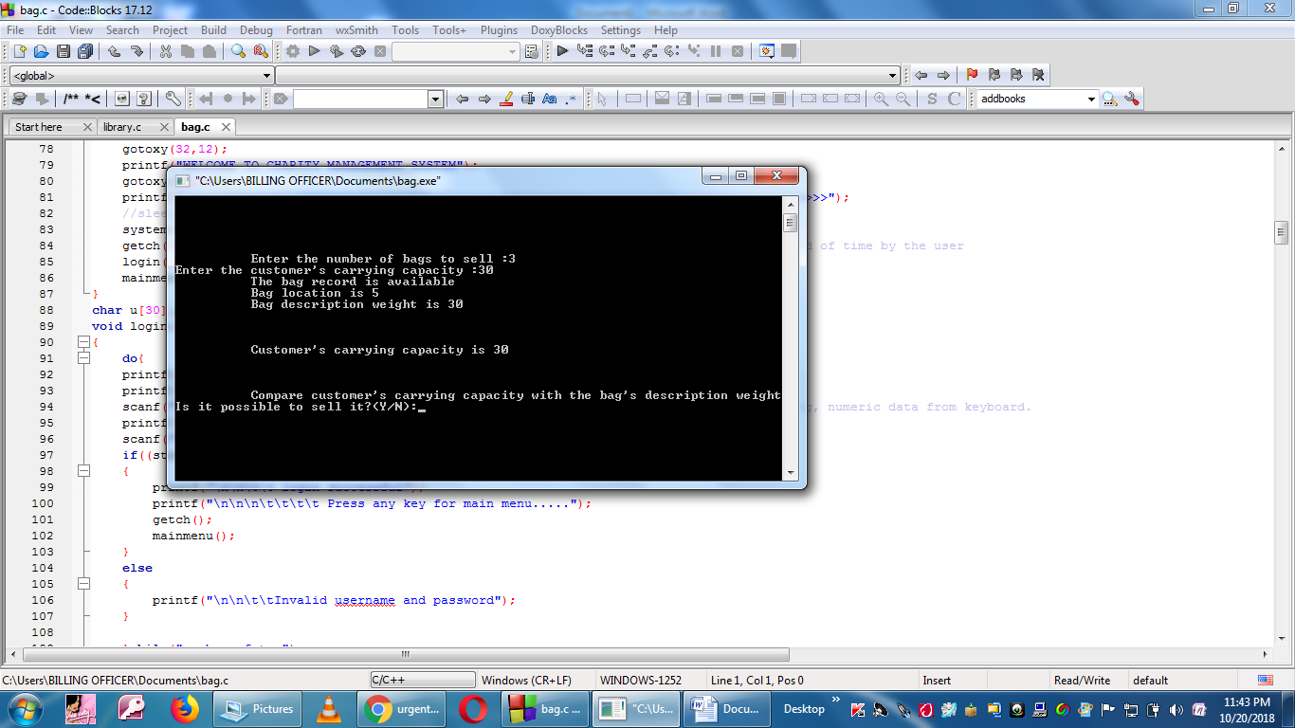

If the user opts for the third option in the main menu, the the program is terminated.
This how it will be;

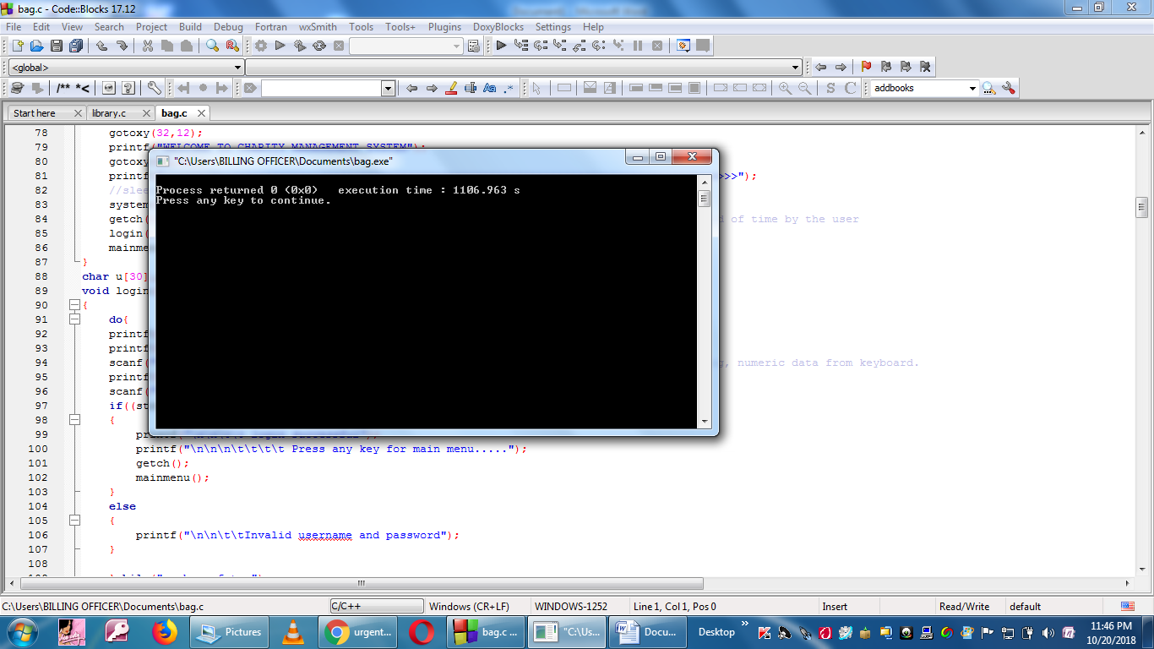

Kindly follow the comments I included, they will direct you so easily.

